I. Phylum: Nematoda (roundworms)
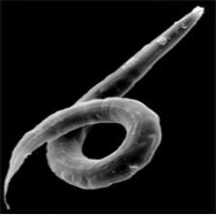
1. Non-segmented worms
2. Longitudinal muscles
3. Alimentary canal
4. No circulatory system
5. Ubiquitous in the environment
6. Free living and parasitic
- Filariasis nematode can cause elephantiasis (aka elephantitis)
- Trichinosis caused by nematode larvae encysted in muscle.
- Guinea worm –Rod of Asclepius may be based on this nematode
II. Phylum: Arthropoda (jointed feet)
- Unifiying traits
1. Bilateral symmetry
2. Segmented body
3. Hard exoskeleton
a. desiccation resistant
b. Made of chitin
c. muscle attachment
d. molt (ecdysis)
4. Jointed legs
5. Many pairs of limbs that provide specialization
6. complete gut
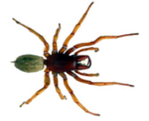
7. open circulatory system
- Evolved from segmented worms
1. Segments fuse over time and specialize
C. Classes (5 classes; trilobites are extinct)
1. Cheliceriformes (spiders, ticks, horseshoe crabs, scorpions)
a. Chelicera - claw-like feeding appendage
b. no antennae
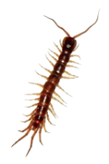
c. cephalothorax - fused head and thorax

2. Myriapoda
a. millipedes (herbivores; 2 pair legs per segment)
b. centipedes (carnivores; 1 pair legs per segment)
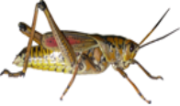
3. Hexapoda (insects)
a. 3 main body parts (head, thorax and abdomen)
b. 3 pair walking legs (hence name, hexapoda)
c. 2 antennae
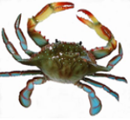

4. Crustacea (crabs, shrimps, barnacles, lobster)
a. Marine and freshwater; a few terrestrial

III. Phylum: Echinodermata (starfish, brittle stars, sea cucumbers, sea urchins, etc)
- Unique characters
1. Deutoerostomes
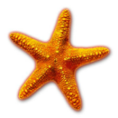
2. Endoskeleton of calcareous plates
3. water vascular system - hydraulic system of closed tubes containing sea water; used for locomotion (tube feet), food and waste transport and respiration
4. larvae bilateral; adults radial symmetry (i.e. radial symmetry is homoplasic)

